**BUTTERFLY AND MOTHS IMAGE DATA STATISTICS, ANALYSIS AND PREDICTION**

**Kanika Mittal**

Department of Computer Science & Engineering

Manipal University Jaipur

Email: [kanikamittal1806@gmail.com](mailto:kanikamittal1806@gmail.com)

***Abstract -* Butterflies and moths play a crucial role in ecosystems as pollinators and indicators of environmental health. Identification and classification of butterfly and moth species is crucial as it provides insights into the impact of climate change, habitat loss, and pollution and it also helps in developing conservative strategies to protect and preserve the diversity of these insects. Therefore, it would be extremely useful to develop predictive models. To resolve this problem, butterflies and moth images data statistics, analysis, and prediction are being utilized.** **The conventional butterfly and moth identification method is based on their different morphological characteristics namely wing-venation, color, shape, patterns, and through dissection studies and molecular techniques which are tedious, expensive, and highly time-consuming. To overcome the above mentioned challenges, a new butterfly and moth identification system using butterfly and moth images has been designed to instantly identify the butterfly and moth with high accuracy**. **This system predicts the species and names of the bufferflies and moths. The main implementation step used in this system is category analysis for which dlib is used. After these, the connection of recognized images ought to be conceivable by comparing with the database containing the images of butterflies and moths. This model will be a successful technique to analyze and predict the categories and names of butterflies and moths.**

***Graphical Abstract -***

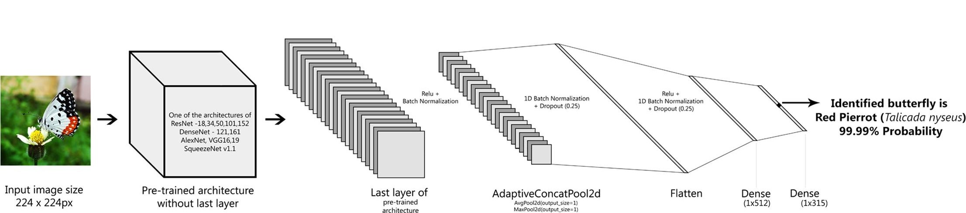

I. INTRODUCTION

Insects form a large portion of the biological diversity of our planet and their population has been declining significantly in recent decades. The butterflies are a class of insects belonging to the Lepidoptera family which accounts for about 9 percent of the world order totalling about 20,400 species.

Butterflies are commonly found in huge numbers on the planet and improve the flora of the surroundings through pollination. This builds up the need for research in this field and has been increasing exponentially. Consequently, there has been a remarkable decline in the diversity and population of these spectacular insects. The survey aims at the detailed study of the various species of butterflies and their impact on biodiversity. It focuses on the integrated system for data regarding the various existing species in various regions making all the data required for research available at a single source. Analysis of the data available will help in creating awareness of the importance of conservation and would help the researchers find solutions for the same problem efficiently. The verified data resource will help in maintaining the integrity of the system. The distribution of butterfly species will be personalized according to the geographical location of the users and will be based on various sectors of occupations.

Progress in the understanding of ecosystems is partly dependent on our ability to find and identify the insects that inhabit them. There is also a need for easy and accurate identification of insects as they are both directly and indirectly related to the survival of humans. Most butterflies are often polymorphic, sexually dimorphic, and exhibit mimicry as a predator prevention strategy. These characteristics of butterflies make butterfly identification quite challenging. The conventional butterfly identification method is based on noting their different morphological characters namely size, wing-venation, color, shape, and patterns and referring to a standard butterfly field guide of the particular country.

To identify butterflies, earlier researchers used texture, color features, Branch Length Similarity (BLS) entropy, and wing shape outline. Some of the earlier research work on butterflies helped to classify a total of 190 butterfly images belonging to 19 different species of the Pieridae family with an accuracy of 98.25% and 96.45% using feature extraction techniques namely Grey-level co-occurrence matrix (GLCM) and local binary patterns (LBP) of butterfly-feature spaces. A total of 50 butterfly specimen images of five species were classified using local binary patterns (LBP). Histograms of multi-scale curvature (HoMSC) and gray-level co-occurrence matrix of image blocks (GLCMoIB) technique were used to classify 750 images of 50 butterflies species which belong to 30 genera of 7 families with an accuracy of 98% (Li and Xiong, 2018). Seven categories of butterflies comprising 619 images were classified using identifying groups of local affine regions (Lazebnik et al., 2004). All the above-mentioned works were based on traditional statistical methods using selective low/mid-level feature identification due to computational resource limitations and as the total number of images and categories used in these datasets were also limited, there is a high chance for the classifiers to misidentify on new images.

For butterfly and moth image analysis and prediction purposes, there is a need for a large data set and complex features. During the recent few years, a good improvement has been made in bufferfly and moth analysis and prediction systems. Currently, most of the butterfly and moth analysis and prediction systems perform well with limited datasets. Moreover, these methodologies have been tested under controlled lighting conditions, proper angles, and non-blurry images. The system that is proposed for butterfly and moth analysis and prediction in this paper is able to recognize multiple species of butterflies and moths in a frame without any control of illumination or position.

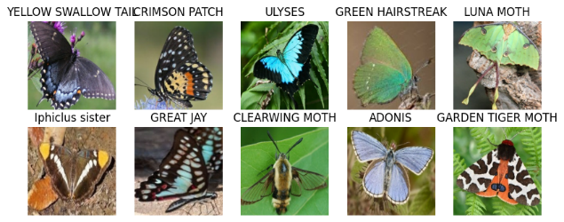

Fig. Some examples of the proposed benchmark, which is quite challenging for a wide range of background complexity, occlusions, and viewpoints.

Even from the above-published study, we observed that the currently available butterfly datasets are limited to fewer species. Moreover, most of these images in the datasets were from preserved laboratory specimens and lacked an adequate number of butterfly images from the natural environment. This limitation of the dataset would serve as a serious deterrent to developing applications for real-time monitoring. As the ratio of butterfly images representing each species is also very low, the classifier could easily get influenced leading to biased classification results. We also found that there were many butterfly datasets representing different countries but none from India.

In this study, we (i) aim to build a huge butterfly dataset from India (ii) propose to use various Deep Convolutional Neural Network architectures (iii) compare the results of top-1, top-3, top-5 accuracies, training loss, and validation loss of trained architectures on the built butterfly dataset to design an accurate butterfly identification system. Logistic regression was used to model the relationship between species distribution and predicted density, based on habitat extent, in each grid square.

II. RELATED WORK

The paper “Identification of Butterfly Species Using Machine Learning and Image Processing” by Ayad Saad ALMRYAD says that the discrimination between butterfly species requires expertise and time, which is not always available, but after the development of software that identifies butterfly species by extracting features from images, the need for experts will reduce. There are two main problems in the existing butterfly species identification research based on computer vision techniques. First, collecting the butterfly dataset is difficult, identifying is time-consuming work for entomologists, and the number of butterflies included in the butterfly dataset is not comprehensive. Second, the butterfly pictures used for training are all pattern pictures with obvious morphological features, lacking the ecological pictures of butterflies in nature. Furthermore, the differences between the two pictures are obvious which makes the combination of research and production difficult and the recognition accuracy is low. Therefore, it is of great importance to conduct research on the automatic identification of butterflies and improve its accuracy and efficiency. The development of tools for automating the identification of butterfly species has an important contribution to the literature.

The article “An Automated Light Trap to Monitor Moths (Lepidoptera) Using Computer Vision-Based Tracking and Deep Learning” by Kim Bjerge says that insect monitoring methods are typically very time-consuming and involve substantial investment in species identification following manual trapping in the field. Insect traps are often only serviced weekly, resulting in low temporal resolution of the monitoring data, which hampers the ecological interpretation. Several of the issues associated with moth classification when the dataset contains a large number of classes have been illustrated. Their work presented a dataset of 636 butterfly and moth species distributed across 14,270 highly detailed images, which were collected using internet search engines. The challenge with such a large dataset of haphazardly collected images is that the variation in image quality, lighting, and posture among individuals of the same species can be quite large. In addition, the dataset consisted of images with complex backgrounds, which makes it difficult to distinguish the individual insects. This makes it necessary to use more complex and larger models such as Visual Geometry Group (VGG), Inception, and Residual Networks (ResNet) to perform classification reliably. Furthermore, training an effective model is challenging with rare species, where there is not enough data.

# The paper “Fine-Grained Butterfly Classification in Ecological Images Using Squeeze-And-Excitation and Spatial Attention Modules” by [Dongjun Xin](https://sciprofiles.com/profile/974012?utm_source=mdpi.com&utm_medium=website&utm_campaign=avatar_name) says that most butterfly larvae are agricultural pests and forest pests, but butterflies have important ornamental value and the ability to sense and respond to changes in the ecological environment. There are many types of butterflies, and the research on the classification of butterfly species is of great significance in practical work such as environmental protection and control of agricultural and forest pests. Butterfly classification is a fine-grained image classification problem that is more difficult than generic image classification. Common butterfly photos are mostly specimen photos (indoor photos) and ecological photos (outdoor photos/natural images). The SA module can make better use of the long-range dependencies in the images, while the SE module takes advantage of global information to enhance useful information features and suppress less useful features. The results show that the integrated model achieves higher recall, precision, accuracy, and f1-score than the state-of-the-art methods on the introduced butterfly dataset.

# 

# The article “Fine-grained Butterfly Recognition with Deep Residual Networks: A New Baseline and Benchmark” by Lin Nie says that insect identiﬁcation is one of the most fundamental challenges in taxonomy and biodiversity studies. At present, most methods propose to identify the species using visual observation by experts, which requires profound professional knowledge and extensive human labor, is tedious, time-consuming, and prone to human errors. In recent years, with the rapid development of computer vision and pattern recognition technologies, automatic identiﬁcation of insects has been more and more paid attention with many advantages such as efﬁciency, rapid and low cost. As a special type of insect, butterﬂy is an important branch of the insect world and one of the most diverse species on earth. Automatically recognizing them by computers can benefit a variety of applications for insects, especially for protecting some endangered species.

# 

# Fig. The tree structure of butterfly data hierarchy

# III. MATERIALS

# In this section, we introduce our new butterfly and moth benchmark a new large-scale dataset focusing on the identification of butterflies and moths which has several appealing properties. The proposed benchmark has 12594 files belonging to 100 classes and another 500 files belonging to 100 classes. The images collected from the indoor/outdoor environments contain challenging viewpoints, heavy occlusion, and various appearances in a wide range of resolutions.

# Diversity: The proposed butterﬂy benchmark contains data from two scenarios, including nature images and standard images. It includes images with varying qualities, resolutions, and conditions which reflects the challenges of working with real-world data, where images may be captured under different lighting conditions, distances, and levels of clarity. Incorporating images with diverse contextual information, such as the presence of other plants, insects, or environmental features will help evaluate the robustness of algorithms in different visual contexts.

# Hierarchy: It includes a broad representation of butterfly and moth species, covering different families, genera, and species. This ensures that the benchmark captures the diversity of Lepidoptera and accounts for variations in wing patterns, colors, sizes, and other morphological features. Also, the structuring of the benchmark according to different life stages enables the evaluation of algorithms in recognizing and analyzing diverse morphological features at each developmental phase. The images are organized based on contextual complexity, such as isolated images, images with cluttered backgrounds, or those with complex visual contexts. This hierarchy evaluates algorithmic adaptability to different image environments.

# 

Fig. Butterflies with different species in the same family. The first row denotes the Lycaenidae family, while the bottom row denotes the Hesperiidae family

**Accuracy:** To collect a highly accurate butterﬂy dataset, we rely on the experts of classiﬁcation and identiﬁcation of butterﬂy to clean candidate images to get the accurate species labels. Speciﬁcally, we collect the images from Google and other public websites and then clean these images to get accurate species labels. Finally, we get the dataset by cropping the cleaned images using a bounding box around the butterﬂy tightly.

**Scale:** The dataset contains 12594 files belonging to 100 classes and another 500 files belonging to 100 classes. Each image is organized by scientific classification namely family, genus, and species. The images are collected for the following types: 'ADONIS', 'AFRICAN GIANT SWALLOWTAIL', 'AMERICAN SNOOT', 'AN 88', 'APPOLLO', 'ARCIGERA FLOWER MOTH', 'ATALA', 'ATLAS MOTH', 'BANDED ORANGE HELICONIAN', 'BANDED PEACOCK', 'BANDED TIGER MOTH', 'BECKERS WHITE', 'BIRD CHERRY ERMINE MOTH', 'BLACK HAIRSTREAK', 'BLUE MORPHO', 'BLUE SPOTTED CROW', 'BROOKES BIRDWING', 'BROWN ARGUS', 'BROWN SIPROETA', 'CABBAGE WHITE', 'CAIRNS BIRDWING', 'CHALK HILL BLUE', 'CHECQUERED SKIPPER', 'CHESTNUT', 'CINNABAR MOTH', 'CLEARWING MOTH', 'CLEOPATRA', 'CLODIUS PARNASSIAN', 'CLOUDED SULPHUR', 'COMET MOTH', 'COMMON BANDED AWL', 'COMMON WOOD-NYMPH', 'COPPER TAIL', 'CRECENT', 'CRIMSON PATCH', 'DANAID EGGFLY', 'EASTERN COMA', 'EASTERN DAPPLE WHITE', 'EASTERN PINE ELFIN', 'ELBOWED PIERROT', 'EMPEROR GUM MOTH', 'GARDEN TIGER MOTH', 'GIANT LEOPARD MOTH', 'GLITTERING SAPPHIRE', 'GOLD BANDED', 'GREAT EGGFLY', 'GREAT JAY', 'GREEN CELLED CATTLEHEART', 'GREEN HAIRSTREAK', 'GREY HAIRSTREAK', 'HERCULES MOTH', 'HUMMING BIRD HAWK MOTH', 'INDRA SWALLOW', 'IO MOTH', 'Iphiclus sister', 'JULIA', 'LARGE MARBLE', 'LUNA MOTH', 'MADAGASCAN SUNSET MOTH', 'MALACHITE', 'MANGROVE SKIPPER', 'MESTRA', 'METALMARK', 'MILBERTS TORTOISESHELL', 'MONARCH', 'MOURNING CLOAK', 'OLEANDER HAWK MOTH', 'ORANGE OAKLEAF', 'ORANGE TIP', 'ORCHARD SWALLOW', 'PAINTED LADY', 'PAPER KITE', 'PEACOCK', 'PINE WHITE', 'PIPEVINE SWALLOW', 'POLYPHEMUS MOTH', 'POPINJAY', 'PURPLE HAIRSTREAK', 'PURPLISH COPPER', 'QUESTION MARK', 'RED ADMIRAL', 'RED CRACKER', 'RED POSTMAN', 'RED SPOTTED PURPLE', 'ROSY MAPLE MOTH', 'SCARCE SWALLOW', 'SILVER SPOT SKIPPER', 'SIXSPOT BURNET MOTH', 'SLEEPY ORANGE', 'SOOTYWING', 'SOUTHERN DOGFACE', 'STRAITED QUEEN', 'TROPICAL LEAFWING', 'TWO BARRED FLASHER', 'ULYSES', 'VICEROY', 'WHITE LINED SPHINX MOTH', 'WOOD SATYR', 'YELLOW SWALLOW TAIL', 'ZEBRA LONG WING'.

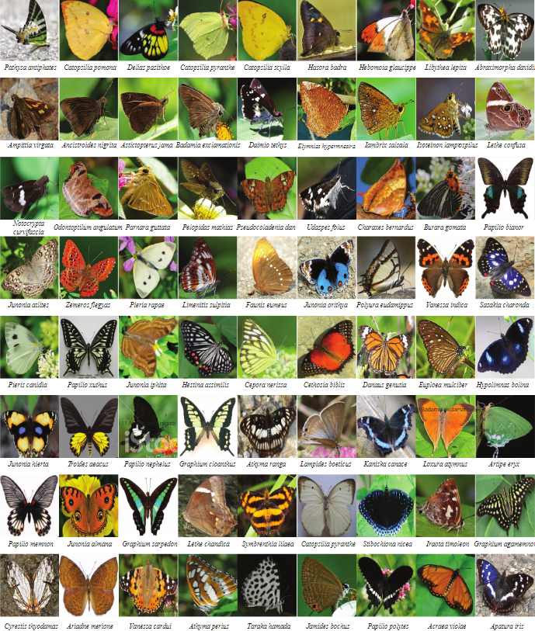

Fig. The demo images for butterflies and moths.

IV. METHODS

**1. Deep Neural Network:**

[Deep learning](https://www.sciencedirect.com/topics/engineering/deep-learning), especially in recent years, has become key research for applications based on [artificial intelligence](https://www.sciencedirect.com/topics/computer-science/artificial-intelligence). Due to the serious achievements in the field of [computer vision](https://www.sciencedirect.com/topics/engineering/computervision), [natural language processing](https://www.sciencedirect.com/topics/computer-science/natural-language-processing), and speech recognition, the rate of use increases day by day.

Deep learning algorithms based on [Artificial Neural Networks](https://www.sciencedirect.com/topics/computer-science/artificial-neural-network), inspired by a simplification of neurons in a human brain, come to the forefront with their success in the learning phase. Deep learning algorithms can solve the problem of feature extraction and selection by automatically removing the distinguishing features from the given input data. Much more labeled data is needed for deep learning compared to classic [neural networks](https://www.sciencedirect.com/topics/computer-science/neural-network). The rapid increase of achievable data today has made the role of deep learning very important in problem-solving. These remarks have attracted the attention of many researchers in the field of computer science.

Convolutional Neural Networks (CNNs), regarded as the fundamental architecture of deep learning, is a Multi-Layer Perceptron (MLP) forward-feed neural network inspired by the vision of animals. CNNs are deep learning models that are mainly used for [image classification](https://www.sciencedirect.com/topics/computer-science/image-classification), similarity detection, and object recognition.

CNNs can identify Faces, Persons, Signs, etc. CNNs, which focus mostly on image classification, are now used in almost every area requiring classification The general CNN structure consists of several consecutive convolutions and pooling layers, one or more fully connected layers, and in the end the output layer (the softmax layer) for classification.

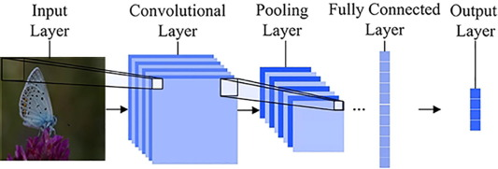

**2. ResNet:**

It has a different structure than the traditional consecutive [network architectures](https://www.sciencedirect.com/topics/computer-science/network-architecture) such as VGGNet, AlexNet, because it has a micro-architectural module structure that differs from other architectures. It may be preferable to switch to the lower layer by ignoring the change between some layers. This situation is allowed in the architecture of ResNet and the success rate of the network is increased by eliminating the problem of memorizing the network. ResNet architecture has a network of 177 layers. In addition to this layered structure, there is information about how inter-layer connections will occur. This model has trained for images of size 224 × 224 × 3.

**3. Adam:**

This model shows the construction of a neural network model using the Keras framework, specifically for a deep learning task such as image classification. The model begins with the addition of a pre-trained base model (base_model), often a convolutional neural network (CNN) with learned features. Following this, a Flatten layer is introduced to transform the multi-dimensional output from the convolutional layers into a flat vector. Subsequently, a Dense layer with 512 units and rectified linear unit (ReLU) activation is added, introducing a dense, fully connected layer to the network. The ReLU activation helps introduce non-linearity to the model. To mitigate overfitting, a Dropout layer with a dropout rate of 0.5 is included, randomly deactivating a portion of neurons during training. Finally, the model concludes with another Dense layer having 100 units and a softmax activation, suitable for a classification task with 100 classes. The softmax function normalizes the output into probability distributions, enabling the model to predict class probabilities for the given input. The model's parameters are optimized during training using the Adam optimization algorithm, which adapts learning rates for each parameter individually, enhancing the convergence speed and overall performance of the neural network.

**4. PIL:**

PIL (Python Imaging Library) or its successor, Pillow, is frequently employed in machine learning models primarily for efficient image processing and manipulation. In the realm of computer vision, where visual data is integral, PIL plays a crucial role in loading, preprocessing, and augmenting image datasets. It provides functionalities for resizing, cropping, and converting images, ensuring compatibility with the input requirements of machine learning models. Additionally, PIL is instrumental in data augmentation, a common practice to enhance model generalization by introducing variations to the training dataset through transformations like rotation, flipping, and changes in brightness. Furthermore, PIL is utilized for visualizing images during model development and evaluation, aiding researchers and practitioners in understanding input data characteristics and assessing model performance. Its versatility extends to tasks such as overlaying annotations, saving processed images, and facilitating seamless integration of visual data into the machine learning workflow. Overall, PIL is a valuable tool in the machine learning toolbox, streamlining image-related operations and contributing to the success and efficiency of computer vision models.

**5. K-Nearest Neighbors:**

We implemented a machine learning pipeline for feature extraction using a pre-trained neural network and subsequently applied the k-nearest neighbors (KNN) algorithm for classification. Initially, an intermediate layer model is created to extract features from the penultimate layer of a pre-existing neural network (denoted as 'model'). The dataset is then passed through this intermediate model to obtain features for training, validation, and testing sets. The extracted features are flattened to be compatible with the input requirements of the KNeighborsClassifier.

A KNeighborsClassifier is instantiated with a specified number of neighbors (k=5). The flattened features from the training set are used to train the KNN classifier. Subsequently, the classifier is employed to predict the labels for the test set based on their extracted features. The code calculates and prints the accuracy score of the KNN classifier on the test set and generates a confusion matrix to provide a detailed breakdown of classification results. The accuracy score reflects the proportion of correctly classified instances, while the confusion matrix provides insights into the number of true positive, true negative, false positive, and false negative predictions. Overall, the evaluation of the KNN classifier's performance on the given dataset using features extracted from a pre-trained neural network.

**6. Decision Tree**

A Decision Tree classifier for a machine learning task using features extracted from a pre-trained neural network is used. Initially, an intermediate layer model is created to obtain feature vectors from the penultimate layer of an existing neural network ('model') for the training, validation, and test datasets. These features are then flattened into 2D arrays to comply with the input requirements of the DecisionTreeClassifier from the scikit-learn library.

A Decision Tree classifier is instantiated, and the flattened feature vectors from the training set are used to train the classifier. Following training, the classifier is applied to predict labels for the test set based on their respective feature vectors. The code calculates and prints the accuracy score, which represents the proportion of correctly classified instances, and generates a confusion matrix to provide a detailed breakdown of true positive, true negative, false positive, and false negative predictions.

In summary, this algorithm is extraction of features from a neural network's intermediate layer and employs a Decision Tree classifier to predict labels for a test set, subsequently evaluating the classifier's performance through metrics such as accuracy and a confusion matrix.

**7. Support Vector Machine**

Support Vector Machine (SVM) classifier for a machine learning task using features extracted from a pre-trained neural network is used. Initially, an intermediate layer model is established to obtain feature vectors from the penultimate layer of an existing neural network ('model') for the training, validation, and test datasets. Subsequently, the 4D feature vectors are flattened into 2D arrays to suit the input requirements of the SVM classifier.

The SVM classifier is instantiated with a linear kernel and a regularization parameter (C) set to 1.0. To enhance the SVM's performance, the code includes feature scaling using the StandardScaler from scikit-learn, which standardizes the feature vectors. The training features are scaled using the fit_transform method, while the validation and test features are scaled using the transform method with the scaler trained on the training set.

The SVM classifier is then trained using the scaled training features, and predictions are made on the test set. The code calculates and prints the accuracy score, representing the proportion of correctly classified instances, and generates a confusion matrix to provide a detailed breakdown of true positive, true negative, false positive, and false negative predictions.

In summary, this algorithm combines feature extraction from a neural network's intermediate layer, feature scaling for SVM, and the application of a linear SVM classifier to predict labels for a test set. The performance of the SVM classifier is evaluated using metrics such as accuracy and a confusion matrix.

V. EMPIRICAL STUDY OF STATE-OF-ARTS

In this section, we analyze the performance of leading image classiﬁcation approaches on our proposed benchmark. In our proposed evaluation setting, we have conducted a detailed analysis of various percentages of training samples. The objective of this analysis is to evaluate the robustness of the current approaches in various challenges for butterﬂy classiﬁcation and identify the existing limitations to stimulate further research advances. In the conducted analysis, we consider the existing deconvolution Neural Networks (CNN) with different algorithms, i.e., ResNet, K-Nearest Neighbor, Decision Tree, and Support Vector Machine approaches, which all have achieved excellent performance on the large-scale ImageNet challenges for image classiﬁcation. All of these considered networks are trained on the ImageNet classiﬁcation task and ﬁne-tuned with the butterﬂy images for butterﬂy classiﬁcation. The experiments are conducted by randomly splitting the images into the training and testing set according to the given training ratio, which ranges from 5% to 50%. Note that, 5%denotes that only 5% annotated images of the whole dataset are employed for ﬁne-tuning the network while the rest 95% are employed for the testing. Since the validation set is required by the considered methods, we randomly select several training samples to avoid overﬁtting. For a fair comparison, we train each approach on our proposed benchmark and evaluate the test set following the same setting. As for the evaluation metric, we employ the mean recognition accuracy of all the butterﬂy and moths categories.

|  |  |
| --- | --- |
| **Model** | **Accuracy** |
| ResNet | 92.04 |
| Decision Tree | 85.4 |
| KNN | 85.2 |
| SVM | 80.5 |

**1. Overall Performance Evaluation**

We start our analysis by reporting the overall butterﬂy classiﬁcation performance of each compared approach and summarizing the results. On the test set of our proposed benchmark, among all approaches, ResNet performs consistently better than others by a clear margin. This demonstrates the superior performance of ResNet. However, as one can observe, ResNet can only obtain 74.6% recognition accuracy when the percentage of training samples is 5%. Though this accuracy is significantly higher than that of other algorithms used, it is not acceptable for the practical usage of butterﬂy classiﬁcation. Fine-grained butterﬂy recognition still has a long way to go. This is due to the insufﬁcient training samples to ﬁne-tune

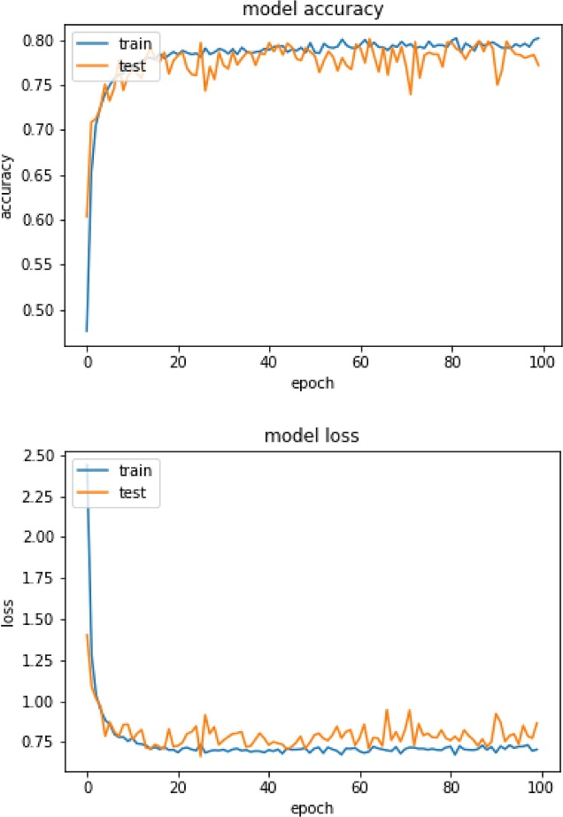

Fig. Decision tree model accuracy and loss curve

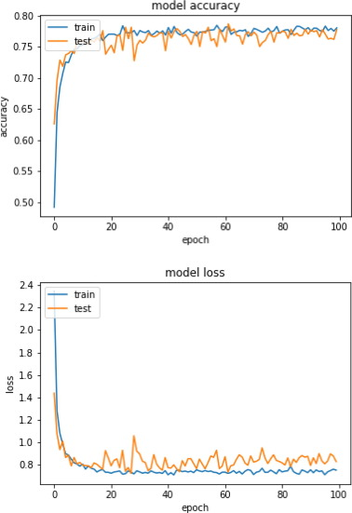

Fig. SVM model accuracy and loss curve

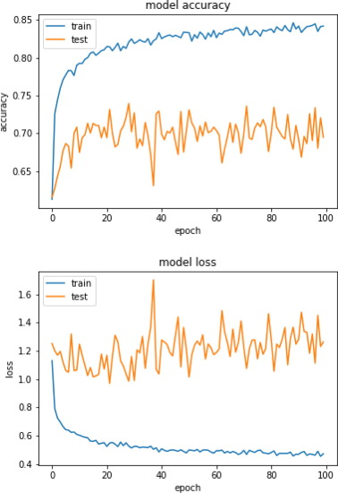

Fig. ResNet model accuracy and loss curve

V1. EXPERIMENT AND DISCUSSION

In this study, various deep-learning models are used to classify the images in the dataset. Convolution Neural Networks based on learning transfer methods were used. The most widely used models in the literature have been trained on the ImageNet dataset and have achieved high success. In this study, fine-tuned transfer learning methods are used for the classification of the butterfly images. Four characteristics of shape, texture, light, and vein are used in the conventional identification theory to distinguish different butterfly species. According to several studies, due to the colorful scales on the wings, it was discovered that the vein features were tough to acquire from the digital image of the butterflies. Butterfly specimens would have different colors for the same species due to the different preservation periods. However, after the full metamorphosis, the form and texture of the butterfly wings are relatively stable. The shape of different samples of similar species is less variable than the texture. In addition, there is a significant difference between different species in the shape of butterfly wings. The shape characteristics are therefore used for the identification of the basic level and the texture characteristics are used for further identification. Many feature selection techniques are now being used widely in these days, such as Convolutional Neural Networks (CNNs), Independent Component Analysis (ICA), Principal Component Analysis (PCA), and Linear Discriminant Analysis (LDA), this analysis will concentrate on Convolutional Neural Networks (CNN).

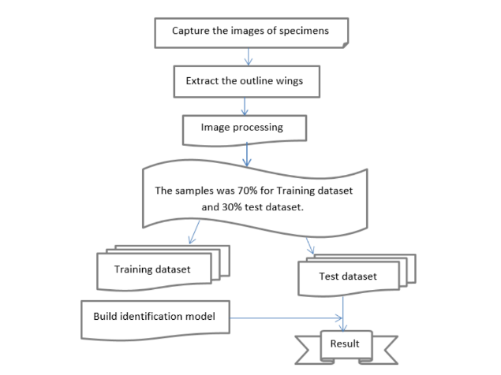

V11. CONCLUSION

In this paper, a field-based dataset was created using butterfly and moth images which are classified by expert entomologists taken from nature. The input images of butterflies are classified with deep learning architectures without using any feature extraction method. Transfer learning was carried out using pre-trained models. Comparison and evaluation of the experimental results obtained using different network structures are conducted. According to the results, the highest success was achieved by Resnet architecture. Although the images have some problems such as the position of butterflies, the shooting angle, butterfly distance, occlusion, and background complexity, approximately 80% success was achieved for both test and training data.

A new butterﬂy recognition benchmark has been proposed to promote image classiﬁcation research. Innovative and distinctive features of the benchmark are scalability, diversity difﬁculty, and public availability. In addition, this work focused on the construction of butterﬂy benchmark and the detailed comparisons of the state-of-the-art image classiﬁcation approaches. Further validation and testing are needed on adding attributes and part locations for each species to make the benchmark useful for attribute prediction and butterﬂy veriﬁcation.

VIII. REFERENCES

[1] A. Krizhevsky, I. Sutskever, and G. E. Hinton, “Imagenet classiﬁcation with deep convolutional neural networks.” in Advances in neural information processing systems (NIPS), 2012.

[2] S. Maji, J. Kannala, E. Rahtu, M. Blaschko, and A. Vedaldi, “Fine-grained visual classiﬁcation of aircraft,” Tech. Rep., 2013.

[3] C. Wah, S. Branson, P. Welinder, P. Perona, and S. Belongie, “The Caltech-UCSD Birds-200-2011 Dataset,” California Institute of Technology, Tech. Rep. CNS-TR-2011-001, 2011.

[4] M. E. Nils back and A. Zisserman, “Automated ﬂower classiﬁcation over a large number of classes,” in 2008 Sixth Indian Conference on Computer Vision, Graphics Image Processing, Dec 2008, pp. 722–729.

[5] F. Zhou and Y. Lin, “Fine-grained image classiﬁcation by exploring bipartite-graph labels,” in The IEEE Conference on Computer Vision and Pattern Recognition (CVPR), June 2016.

[6] X. Zhang, H. Xiong, W. Zhou, W. Lin, and Q. Tian, “Picking deep ﬁlter responses for ﬁne-grained image recognition,” in The IEEE Conference on Computer Vision and Pattern Recognition (CVPR), June 2016.

[7] M. Silveira and A. Monteiro, “Automatic recognition and measurement of butterﬂy eyespot patterns,” Biosystems, vol. 95, no. 2, pp. 130 – 136,2009.

[8] Y. Kaya, L. Kayci, and N. Sezgin, “Classiﬁcation of butterﬂy images with multi-scale local binary patterns,” in 2013 21st Signal Processing and Communications Applications Conference (SIU), 2013, pp. 1–4.

[9] L. Kayci and Y. Kaya, “A vision system for automatic identiﬁcation of butterﬂy species using a grey-level co-occurrence matrix and multinomial logistic regression,” Zoology in the Middle East, vol. 60, no. 1,pp. 57–64, 2014.

[10] L. Kayci, Y. Kaya, and T. Ramazan, “A computer vision system for the automatic identiﬁcation of butterﬂy species via gabor-ﬁlter-based texture features and extreme learning machine: Gfelm,” TEM J.,vol.2,no. 1, pp. 13 – 20, 2013.

[11] J. Wang, K. Markert, and M. Everingham, “Learning models for object recognition from natural language descriptions,” in Proceedings of the British Machine Vision Conference, 2009.

[12] O. M. Parkhi, A. Vedaldi, A. Zisserman, and C. V. Jawahar, “Catsand dogs,” in the IEEE Conference on Computer Vision and Pattern Recognition (CVPR), 2012, pp. 3498–3505.

[13] N. Kumar, P. N. Belhumeur, A. Biswas, D. W. Jacobs, W. J. Kress,I. C. Lopez, and J. V. B. Soares, “Leaf snap: a computer vision system for automatic plant species identiﬁcation,” in European Conference on Computer Vision(ECCV), 2012, pp. 502–516.

[14] J. D. Wegner, S. Branson, D. Hall, K. Schindler, and P. Perona, “Cataloging public objects using aerial and street-level images - urban trees,” in the IEEE Conference on Computer Vision and Pattern Recognition(CVPR), 2016, pp. 6014–6023.

[15] L. Yang, P. Luo, C. C. Loy, and X. Tang, “A large-scale car dataset for ﬁne-grained categorization and veriﬁcation,” in the IEEE Conference on Computer Vision and Pattern Recognition (CVPR), 2015, pp. 3973–3981.

[16] D. Hall and P. Perona, “Fine-grained classiﬁcation of pedestrians in video: Benchmark and state of the art,” in the IEEE Conference on Computer Vision and Pattern Recognition (CVPR), 2015, pp. 5482–5491.731Table of Contents

[17] M. Rohrbach, S. Amin, M. Andriluka, and B. Schiele, “A database for ﬁne grained activity detection of cooking activities,” in the IEEE Conference on Computer Vision and Pattern Recognition (CVPR), 2012,pp. 1194–1201.

[18] V. H. Grant, M. A. Oisin, S. Yang, S. Alex, A. Hartwig, P. Pietro, and B. Serge, “The inaturalist challenge 2017 dataset,” 2017.

[19] A. Krizhevsky, I. Sutskever, and G. E. Hinton, “Imagenet classiﬁcation with deep convolutional neural networks,” in NIPS, 2012.

[20] J. Deng, W. Dong, R. Socher, L.-J. Li, K. Li, and L. Fei-Fei., “Imagenet: A large-scale hierarchical image database,” in CVPR, 2009.

[21] P. Agrawal, R. Girshick, and J. Malik, “Analyzing the performance of multilayer neural networks for object recognition,” in ECCV, 2014.

[22] J. Hoffman, S. Guadarrama, E. S. Tzeng, R. Hu, J. Donahue, R. Girshick, T. Darrell, and K. Saenko, “Lsda: Large scale detection through adaptation,” in Advances in Neural Information Processing Systems,2014, pp. 3536–3544.

[23] K. Wang, X. Wang, L. Lin, M. Wang, and W. Zuo, “3d human activity recognition with reconﬁgurable convolutional neural networks,” in ACMMM, 2014.

[24] K. Simonyan and A. Zisserman, “Very deep convolutional networks for large-scale image recognition,” in ICLR, 2015.

[25] K. He, X. Zhang, S. Ren, and J. Sun, “Deep residual learning for image recognition,” in The IEEE Conference on Computer Vision and pattern recognition (CVPR), June 2016.